Homepage: https://xd.adobe.com/view/72492b79-7582-4737-9939-97589426b847-271a/
SEO Information –
Meta Title: Welcome to Ribbon People website

Meta Description: For all your Gift wrapping, event and crafting ribbon accessories
Keyword: Ribbon, ribbons, printed, tartan, satin, double faced satin, single faced satin, polyester, grosgrain, wire edge, wired, polka dot, organza, striped, rainbow, table runner, gift bags, tie top bags, gift wrap, elastic, rattail, paper, raffia, staring, jute, paper covered wire, flag, flower, herringbone, glitter, lurex, string, cord, curling, lanyard, Bowdabra, bow maker, pullbow, Christmas, Easter, Birthday, wedding, Christening, Baby, mother’s day, Halloween, anniversary, bows, gems, lace, gift tags, balloons, bunting, accessories, swatches

Keyword:
__________________________________________________________________________________
Section 1 – Homepage Banner Slider:
Image Name | Title | Subtext | Button title | Where to link to
s1bs1_ribbon.jpg | Save 10% on printed ribbon | Don’t forget the important finishing touch to any gift | Shop Now | Ribbons category
s1bs2_tablerunner.jpg | Stunning Table Runners | Decorate your table for special occasions. | Shop Now | Table Runners category
s1bs3_accessories.jpg | Fabulous Accessories | Accessories to compliment you craft. | Shop Now | Accessories category

Section 2 – USPs:
Leave blank if you would like to use the same ones from the design, otherwise please provide new content

Section 3 – Text banner:
Text: e.g., Earn loyalty points for discounts of your future orders whilst you spend. Get 100 points for every £1 you spend!

Section 4 – About Ribbon People
Title: About Us
Text: With over 15 years of experience selling ribbons and accessories our collection spans a wide range of beautiful ribbons in many different types, colours, widths and styles. If you want it, we have got it! Choose by occasion, colour or type, buy by the roll or metre. Running alongside our ribbons we have a stunning collection of table runners, gift bags and many other accessories to compliment your special occasion, gift wrap, card making and craft.

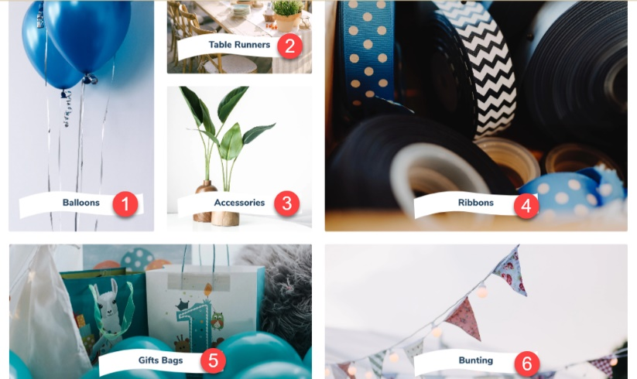
Section 5 – Categories ad blocks

Block # | Image Name | Title | Page /Category to link to
1 | s5b1_ribbon.jpg | Ribbons | Ribbons
2 | s5b2_tablerunner.jpg | Table Runners | Table Runners
3 | s5b3_giftbags.jpg | Gift Bags & Bows | Gift Bags
4 | s5b4_bunting.jpg | Bunting | Bunting
5 | s5b5_accessories.jpg | Accessories | Accessories
6 | s5b6_balloons.jpg | Balloons | Balloons

Section 6 – Ad block
Image 1 (background): s6img1bg.jpg
Image 2 (foreground): s6img2fg.jpg
Title: Don’t forget the Table Runner
Text: Our table runners come in different widths, lengths and materials; some can be cut to size. We have a runner for all occasions, why not take a look
Button title: Shop Now Button Link: Table Runners

Section 7 – Occasions
Title: Occasions
Text: To help you find the right thing for your special event we have sorted and grouped our products into the sort of occasions you may want to buy for. You can also search by colour, material or pattern, whatever you find the easiest way to look.
Ad blocks x 8:
Block # | Image Name | Title | Page /Category to link to
1 | s7b1_baby.jpg | Baby & Birth
2 | s7b2_birthday.jpg | Birthday
3 | s7b3_christmas.jpg | Christmas
4 | s7b4_giftwrap.jpg | Gift Wrap
5 | s7b5_seasonal.jpg | Occasional & Seasonal
6 | s7b6_party.jpg | Party
7 | s7b7_pride.jpg | Pride
8 | S7b8_weddings.jpg | Wedding & Engagement
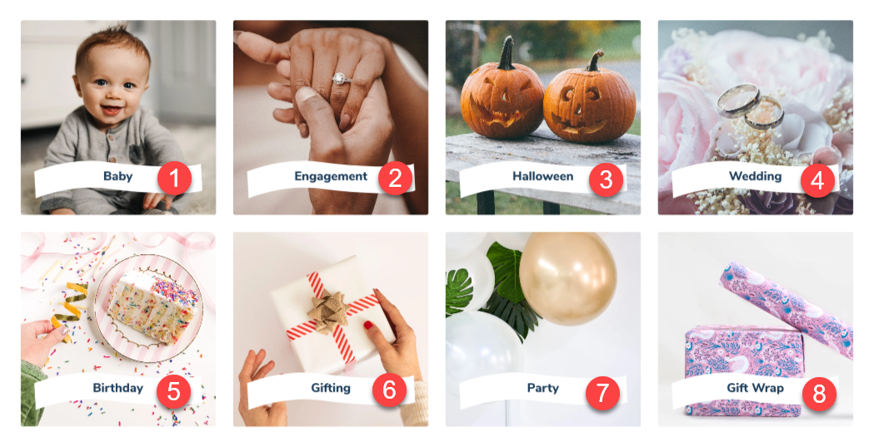

Section 8 – Ad block
Image: s8_adblock
Title: Our Ribbons
Text: A large number of our ribbons are manufactured here in the UK giving you a beautiful and luxurious end product. With so many colours to choose from and so many varieties of not just ribbons but silk cords, wired products we know you will find what you are looking for.
Button 1 title: Ribbon Button 1 Link: Ribbons
Button 2 title: Button 2 Link:

Section 9: News Articles
Title: Get Inspired
Text: To help you get the very best results from our lovely ribbons we have researched some great videos showing you how to giftwrap and how to make wonderful bows, why not watch and learn!
How to gift wrap:
https://youtu.be/vArhcqmPP2c
https://www.youtube.com/watch?v=GBmOLlU-_Vk
How to tie a bow:
https://www.youtube.com/embed/4Ehp5Kf9pGM

Button Title: E.g., Explore more Button link: News listing page
*Articles to be provided separately*

Footer:
YouTube Link:
Facebook Link:
Twitter Link:
Instagram Link:

