Design: https://xd.adobe.com/view/4ed1f036-a8be-45c6-85c1-144f0b95d6ea-1b82/

SEO Information –
Meta Title: Frequently asked questions
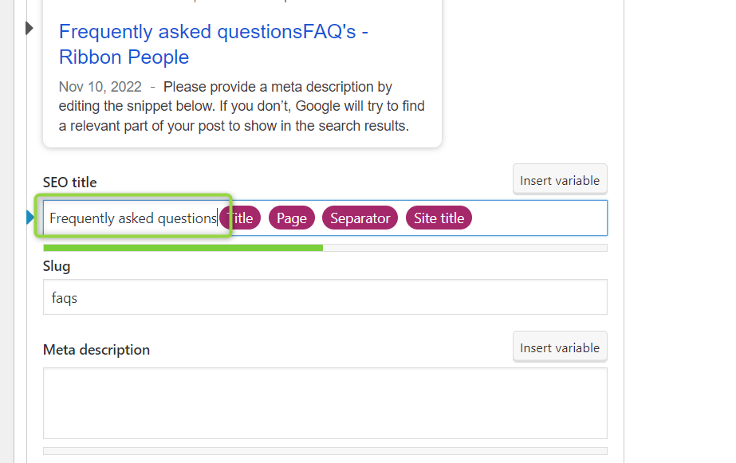
Meta Description: Delivery, tracking, post, cost, shipping, carriage, out of stock, courier, am, pm, received, delete, cancel, working, items, online, minimum, different, address, email, telephone, number

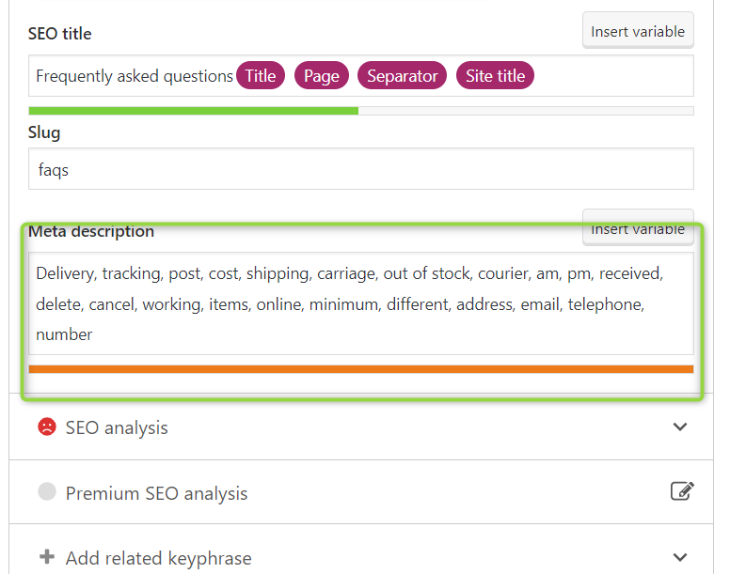

Keyword: questions
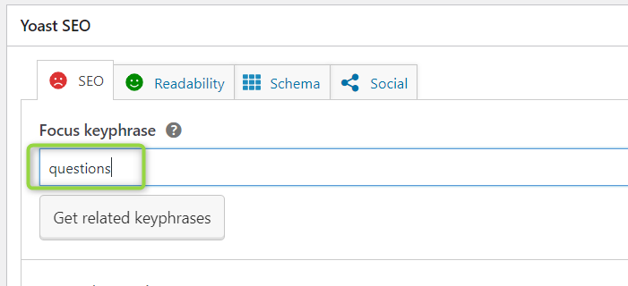

__________________________________________________________________________________
Section 1 – Intro
Title:
Text:
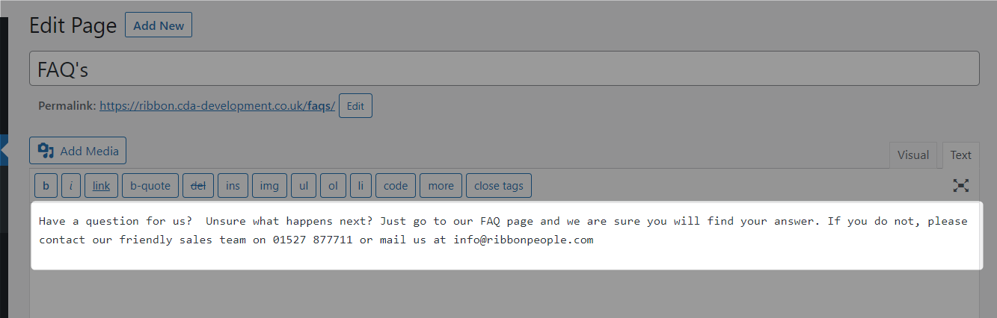

Section 2 – FAQs
FAQs and categories to be provided via spreadsheet

Section 3 – Categories ad blocks (Left as is as it was matching the design)
Leave blank if you would like to use the same content as on the homepage
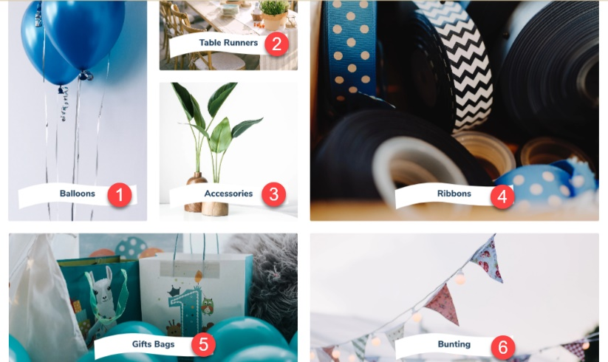

Block # | Image Name | Title | Page /Category to link to
1
2
3
4
5
6

Section 4 – Articles (Left as is as it was matching the design)
Same as homepage

